learning through internships

connect ∙ contribute ∙ authentic
Parent Information

What is the Learning through Internship Course?

The Learning through Internships (LTI) program offers a myriad of career experiences for students developed jointly by the school and businesses in the context of a supported structured classroom environment.

At the beginning of this course, students continue the discovery of their strengths, interests, values, and preferences related to a work experience. Students study specific careers and career paths as related to their personal interests and future goals. Students develop soft skills that are important to employers prior to being placed in a work environment. Students practice communication, problem solving, and teamwork all related to being on the job. After the initial phase of the course is completed students meet with their mentor/partner business to discuss their specific internship experience. While every internship experience is unique, all students are expected to make a contribution to the partner business and to connect what they are learning on the job with content from their classroom experiences at the high school.
The goal of Perry Local School’s Learning through Internship course is to advance college/career-bound students’ academic, intellectual, technical, and personal skills though an authentic learning experience in which they have real world connections between school and work.
Both the summer internship experience and the semester based experiences move through the phases as listed below. The summer internship experience is modified due to the fact that students earn only a half-credit in the summer versus the full-credit during the semester.
PHASE I: Preparation for the Internship Experience, students specifically focus on soft skills that are required in the workplace prior to starting their experience. Students begin to fine tune work place communication skills as they ready themselves to meet their mentor and learn about their partner business.
PHASE II: Internship Experience Begins, an internship is a long-term 10-12 week learning experience for preparation for a professional career. Students must complete 60 hours of work for the full credit towards graduation. Summer internship students complete only 30 hours for half-credit. This phase begins with goal setting between the teacher, mentor, and student. These goals will serve as the guideline for the students work throughout the internship. Students in PHASE II are active with their mentor and with their LTI teacher moving from observer to participant in the workplace. Students experience the support of the class within a community of learners and the teacher as they develop their contribution to the partner business and their connection to classroom learning.
PHASE III: Reflection begins when the student, mentor, and teacher experience the complete contribution the student has made and develop a clear understanding of the connection to the content. The contribution made to the business and the connections established by the student align with the goals initially agreed upon by the student, teacher, and mentor business. The student is organizing the experience in order to present findings to the panel.

PHASE IV: Evaluation begins when students, mentor, and teacher assess the goals that were initially established for mastery. This takes place after the final presentation made by the student to the panel. With intentional learning goals, mentorship, and evaluation, interns apply their classroom learning to “real world” experiences, enhancing their education and adding value to the business partner. Typically, students participate in projects alongside practicing professionals as they tackle specific day-to-day challenges.

Why should my son/daughter participate in an internship?
Skills for Living in the World

The Learning through Internship course is designed to prepare students to live, learn, and work in the 21st Century. The four areas indicated the skills that will guide the modules, lessons, and experiences of the learning through internship course. They will be embedded in the classroom and work place experiences students have. The goals established by the mentor, student, and teacher will revolve around these guiding principles.

Skills for Living in the World
Citizenship and Global Awareness
Networking
Empathy
Adaptability
Time Management
Personal and Social Responsibility

Tools for Working
Information Technology
Communications Technology
Information Literacy

Ways of Working
Communication
Collaboration
Relationship Building
Grit

Ways of thinking
Creativity
Critical Thinking
Problem Solving
Decision Making
Risk Taking
Entrepreneurialism

Students benefit from learning in a high-skill environment. They observe all aspects of the company’s operations and discover how the knowledge gained in high school programs is applied in the workplace. This is the essence of the connection the Learning through Internship program requires students to make.
Additional benefits to students:
- Opportunity to “try on” a career and gain work experience
- Confirm a career interest
- Lead a student in a new direction
- First step in building a resume
- Build work ethic and soft skills
- Networking
- Provides confidence building and life skills
- Provide an education you rarely get in a classroom

What will my son/daughter do in his/her internships?
Each internship experience is as unique as the individual student participating. Some students will have active hands on experiences and others will spend time observing and gaining insights about a specific career field through informational interviews and research.
There are many factors to take into account when understanding what your son/daughter will actually DO for the company or business. Sometimes students are not permitted to participate in an element of the day due to age, confidentiality, or other industry restrictions. It’s important to ask questions about the experiences your son or daughter is having at their site, just like you would about their school day. If you ever have any concerns, please contact the teacher.
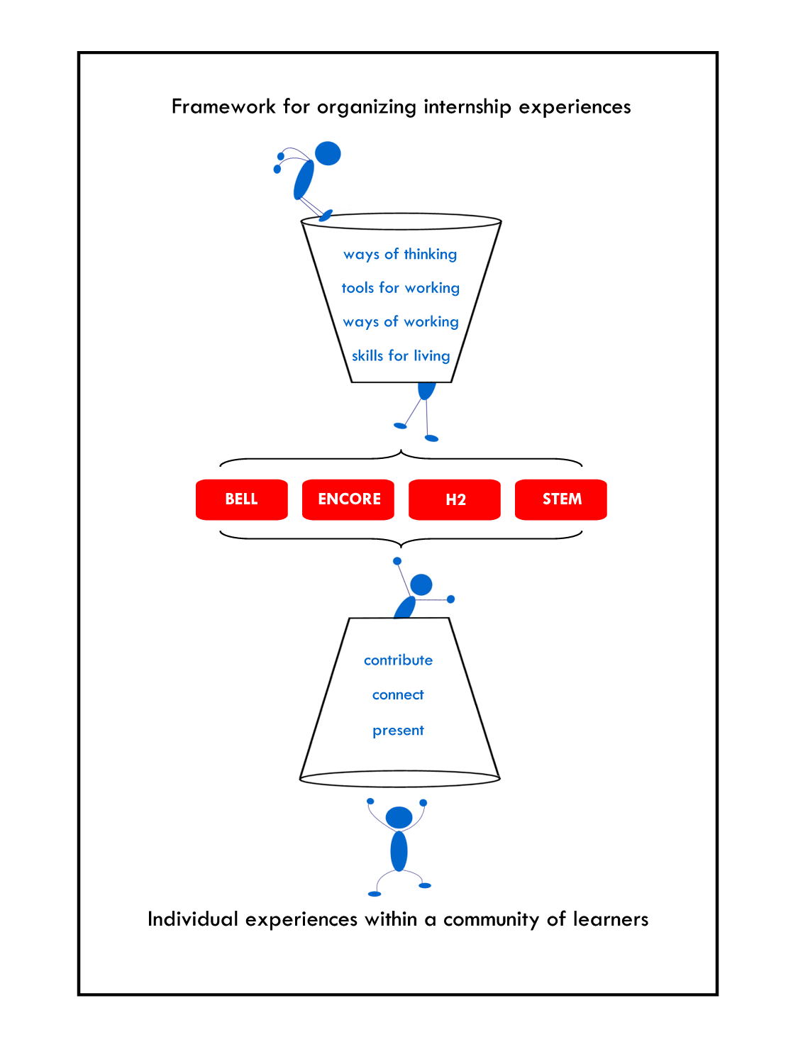
Other important details to know about your son/daughter’s internship
.
- Students experiencing the semester based Learning through Internship course must complete a minimum of 60 hours for the full credit. Travel time is factored into this total of 60 hours.
- This 60 hours counts as a significant portion of a student’s grade. Failure to submit the appropriate documentation of the 60 hours will result in course failure even if the hours are done by the student. There is a specific system students will use to notify the teacher when they complete hours and this will be reviewed extensively with students until all are able to use the system and comfortable with how it works.
- The day/times are arranged individually. The internship may be during the school day, after school, or on weekends. They may also be scheduled over the summer for half-credit, 30 hours. They may be scheduled during the semester for full credit, 60 hours.
- The internship is for an academic credit. The credit is general elective credit and does not count to one of the core requirements needed for graduation. Some company policies may allow paid internships, and that is acceptable.

The internship programs of Perry Local Schools are subject to the Child Labor Laws of the U.S. Department of Labor. Parents, students, and business partners interested in reviewing these stipulations may visit: http://www.dol.gov/whd/regs/compliance/childlabor101_text.htm#11

Student Information
Credits
- To receive credit for the Learning through Internship summer course students must register for the SUMMER STRETCH Boot Camp through the Perry High School website. There is a credit flexibility application that must be completed and the student must get approval from Credit Flex Team. The student must spend the required hours on the application at their internship site and must complete all required assignments.
- To receive credit for the Learning Through Internships semester course students much complete the requirements of the semester course during either fall or spring semester including the 60 hour internship experience.

Attendance
• The internship student confers with his/her mentor to establish a convenient time schedule.
Mentors and students are asked to be flexible. As situations change, schedules may need to be adjusted. The schedule must indicate the days of the week and the hours that the student will be at their internship site.
• Students may not remain at their internship site after stated hours unless they have permission from their mentor and parent/guardian.
• Regular attendance and punctuality are critical. Students should not miss scheduled days at their internship site, and should always arrive on time. If a scheduled day is missed due to a Perry Local Schools (PLS) excused absence, the student must inform the mentor and mutually determine an appropriate time to make up the missed hours. For example, making up missed hours may be done by students attending their internship on any day not regularly scheduled. All make‐up hours must be scheduled with the approval of the mentor. The student must notify the mentor prior to any absence or late arrival to their internship site.
Failure to do so will affect the student’s grade as a portion of the student’s final grade in the Learning through Internship course is based on the student’s weekly time sheet being signed and submitted to the teacher prior to pre-established deadlines. Students must turn in a weekly time sheet (electronically) for both the summer and semester based programs.
• Students are not required to attend their scheduled internship day if it falls on a Holiday or calamity day. However, the student may attend his/her placement on that day if prior arrangements have been made with the mentor.
• During an extended illness or absence, the student and mentor may make alternative arrangements. Students must notify program advisors of any changes in their schedule and/or outline of proposed internship activities.
• For the student, experience, knowledge, and course credit(s) are benefits of the experience.
Paid internships can be arranged. Time spent at the internship site may not be counted as volunteer or community service hours, unless special arrangements are made to acquire those hours after the internship requirement is fulfilled.

*Perry Local Schools excused absences: Student illness, death in the family, observance of religious holiday, school sponsored event with prior approval by mentor.

Grades

Successful completion of all requirements on or before deadlines is imperative.

For the semester based Learning through Internship class, each six week’s grade is based on the student’s performance at their placement site and their performance in the classroom. Students will be graded on the accuracy and quality with which they complete classroom work related to their experience. They will also be graded on their ability to submit a weekly time sheet reflecting their time spent in the field for that week. The overall grade for the course will reflect the students work over the course of the semester both in the field and in the classroom.

The Mentor will complete an evaluation of the student at the end of the second six week grading period and at the end of the final presentation. This evaluation is based on criteria such as student attendance, punctuality, communication, interest level, motivation, reliability, thoroughness, and progress made towards the development of projects.

For the Summer Learning through Internship online experience, one overall grade will be submitted at the end of the 30 hours. Students will be graded on the accuracy and quality with which they complete online assignments related to their experience. They will also be graded on their ability to submit a weekly time sheet reflecting their time spent in the field for that week. The overall grade for the course will reflect the students work over the course of the 30 hours both in the field and in the classroom.

The Mentor will complete an evaluation of the student at the end of the 30 hour summer experience. This evaluation is based on criteria such as student attendance, punctuality, communication, interest level, motivation, reliability, thoroughness, and progress made towards the development of projects.

If a student is not fulfilling his/her responsibilities or is not attending regularly, please notify
Either Rita Soeder (440-259-9320 classroom or 440-205-0019 cell or soederr@perry-lake.org )or Amy Harker (440-259-9200 ext. 9200 or harkera@perry-lake.org) at once so that the situation can be rectified.

When a student fails to submit a weekly time the teacher will follow up with both the student and the mentor. It is at this time that both parties will have the opportunity to voice concerns. Requiring frequent time sheets and communication between school and mentor is a means of proactively protecting the partnership between all parties.

Weekly Time Sheets/ X2Vol (web-based time sheet system)
• Students must maintain a weekly time sheet throughout the Learning through Internship course whether this is for the summer or the semester based experience. Students should duplicate this form as needed. Students are responsible for recording their daily hours and activities at their placement site. The time sheet is to be an accurate reflection of the days and hours spent at the internship site. It is the student’s responsibility to ensure that the time sheet is signed by the mentor and delivered (email, fax, teacher mailbox) to Mrs. Soeder each and every week prior to the predetermined deadline. Failure to submit a signed time sheet prior to the deadline will result in 0 hours for the week. This is factored into a student’s grade. It is possible to fail the Learning through Internship course even though the work is done at school and on site if the time sheets are not consistently signed and submitted prior to the deadline. There are no late time sheets accepted by the teacher. This is done to honor the commitments we have to businesses who support this Internship program.

Student Signature Required ______________________________
Parent Signature Required ______________________________
Date________________

Additional Information
• Students should give their mentor the names and telephone numbers of their parent(s)/guardian(s) in case of emergency. Parent/guardian home, work and cellular phone numbers should be provided.
• Students are to ensure that the mentor or designated person at the placement site knows where they are during their attendance each day at the internship.
• Students should ask their mentor whether there are any clothing requirements and/or limitations. At many placement sites, it is important to wear appropriate and/or specific clothing.
• Students are responsible for all information in the internship manual, as well as any information found in any other document sent or given to them regarding the experience. Students are also responsible for any information given to them by their mentor, and for following internship site regulations.

Student Intern Evaluation
Business Partner Internship
Mid and End of Term
Evaluation
To be completed by Business / Community Partner

Student____________________________________________Date__________________
Supervisor Signature:______________________________Title____________________
Organization Name:_______________________________________________________

Please provide your candid evaluation of the intern student. Students receive a maximum of ___ points based on your evaluation of their performance. These points are reflected in the major grades that they earn at the mid-point and end of their internship assignment.
On a scale of 1 to 5, with 1 being Unacceptable and 5 being Exceptional, please evaluate the intern on the following characteristics:

 | Unacceptable | Needs Improvement | Average | Above Average | Exceptional
Dependability | 1 | 2 | 3 | 4 | 5
Attendance | 1 | 2 | 3 | 4 | 5
Completion of projects | 1 | 2 | 3 | 4 | 5
Quality of work | 1 | 2 | 3 | 4 | 5
Ability to Communicate | 1 | 2 | 3 | 4 | 5
Ability to work on teams | 1 | 2 | 3 | 4 | 5
Problem Solving Skills | 1 | 2 | 3 | 4 | 5
Use of good judgment | 1 | 2 | 3 | 4 | 5
Professional attire | 1 | 2 | 3 | 4 | 5
Initiative | 1 | 2 | 3 | 4 | 5
Skills related to this placement | 1 | 2 | 3 | 4 | 5
What do you perceive to be this student’s greatest strengths?

In what area(s) does this student need to improve?

Please email (soederr@perry-lake.org) or fax (440-259-9290) this form to the attention of the Internship Supervisor, Rita Soeder, at Perry Local Schools. Should you have additional questions, you can also contact the Director of Student Services and College & Career Readiness, Amy S. Harker. harkera@perry-lake.org or phone (259-9200 ext. 9201).
******************************************************************************
School Use Only- (To Be Completed By Internship Supervisor)
Internship Attendance & Completion (_____ Points) __________
Daily Journal & Time Sheet (_____ points) __________
Presentation of Experience (_____points) __________
TOTAL GRADE POINTS __________
Learning through Internship and Business Partnership AGREEMENT

Thank you for providing the students of Perry High School with an opportunity to enhance their education through the internship program.

Name of intern: ________________________________________________________________
Intern phone number:________________________ Number to text:______________________
Intern Email:_______________________________ Preferred way of communicate__________

Name of company providing internship: _____________________________________________
Address: ______________________________________________________________________
Mentor phone number:________________________ Number to text:______________________
Mentor Email:_______________________________ Preferred way of communicate__________
Company fax number: _____________________________________________________________

• The internship will begin __________________ (date) and end ___________________(date).
• The intern will work approximately ___________hours per day, _______days a week.
• The intern will work a 10-12 week time period with a minimum of ____ hours during the intern experience.
• The intern will be assigned a staff member to act as a mentor.
• The intern will be assigned experiences that will assist the company and also allow the student various learning experiences.
• The company agrees to complete an evaluation of the student at midpoint and again evaluate the student and the program also at the end of the internship.
• Professional dress and appropriate conduct is expected of the intern at all times.
• The intern understands that failure to comply with company expectations will result in termination.
• Any problems during the internship shall be referred to the student’s Internship Supervisor.
• Perry High School personnel will visit the work site and be available for assistance.

Business Partner Signature________________________________________Date____________
(This form needs to be completed and a copy kept on file with the Internship Supervisor)

PERRY HIGH SCHOOL CONTACT INFORMATION:
Rita Soeder, Internship Supervisor, soederr@perry-lake.org
440- 259-9320 (during the school day) 440-205-0019 (summer or after school hours)

Perry High School Learning through Internship Weekly Time Sheet

_____________________________________
Student’s Name Printed
________________________ _____________________________
Mentor’s Name Printed Internship Site

Instructions: Duplicate this form. Each student is required to maintain a record of his/her
daily attendance and activities. Time Sheet is to be delivered or emailed by the student to Mrs. Soeder no later than Friday’s at 3:00pm.
Date | Time In | Description of Activity | Time Out | Hours | Mentor's Initials

Student Signature:_________________ Mentor Signature: _______________________

Perry High School Learning through Internship Weekly Time Sheet

_____________________________________
Student’s Name Printed
________________________ _____________________________
Mentor’s Name Printed Internship Site

Instructions: Duplicate this form. Each student is required to maintain a record of his/her
daily attendance and activities. Time Sheet is to be delivered or emailed by the student to Mrs. Soeder no later than Friday’s at 3:00pm.
Date | Time In | Description of Activity | Time Out | Hours | Mentor's Initials

Student Signature:_________________ Mentor Signature: _______________________
Here’s what information our Mentors are given about managing Interns
Because interns are students, managing them takes special attention. This internship may be among their first professional experience.
Orientation: Take time the first day to orient the intern to the office, introducing the intern to the staff members and providing an overview of the organization. It is helpful to identify particular staff members the interns should go to for help with office procedures if their mentor is not available.
Expectations: Discuss your expectations of the student’s performance and expectations of the internship experience. Write down these expectations and review them on a regular basis. Students are expected to follow your company’s policies and procedures during the internship. Students are also expected to continue to follow all Perry Local School District policies and procedures. In addition to general expectations the mentor, intern, and teacher are expected to develop a set of objectives relating to the experience. The mentor can refer to these throughout the student’s experience as the student will use them as a guide for their course work when they are at the high school for class.
Concerns: Contact the Internship Coordinator, Rita Soeder, or Director of College and Career Readiness if you have any concerns about the intern’s ability to successfully complete the internship.
Contact information:
- Internship Coordinator: Rita Soeder at soederr@perry-lake.org Phone (440) 259-9230 or (440) 205-0019.
- Director of College and Career Readiness: Amy S. Harker at harkera@perry-lake.org, phone: 259-9200 ext. 9201.
Evaluation: Students will be graded based upon your evaluations of their performance as well as the project and/or presentation at the conclusion of their experience. Grades also factor in the students time sheets and their assignments done for the course being taught at the high school that accompanies this Learning through Internship experience.

PERRY HIGH SCHOOL
Learning Through Internships
Waiver of Claims, Release of Liability and Covenant Not to Sue
I/We hereby request that [Name of Student] (hereinafter “the Student”) participate in the Perry High School Learning Through Internship Course. In exchange for the opportunity to participate in the Internship. I/We acknowledge that I/We have been informed about the nature of the Internship and the manner in which it will be conducted. Having such knowledge, I/We sign this Waiver of Claims and Release of Liability and Covenant not to Sue:

1. This is a legally binding Waiver of Claims, Release of Liability and Covenant not to Sue made by and on behalf of the Student.

2. I/We understand that the Perry Local School District will not be providing, nor will be responsible in any way for the Student’s transportation for the Internship. Instead each Student will be responsible for the Student’s transportation to and from the interviews and visits to appropriate agencies. In this regard, I also understand and appreciate the significant dangers associated with the Student’s responsibility for providing his/her own transportation in relation to an Internship, and understand and agree that I/we have assumed all risks involved with transportation related to any facet of the Learning Through Internship Course.

4. I/We understand that while Perry High School personnel have made arrangements with many of the agencies/individuals participating in the Learning Through Internship Course to accept Perry High School Students for their individual internships, Perry Schools personnel will not be present for the Student’s participation in any of the activities the Student undertakes or participates in with the business, agency/assigned mentor. I/We also understand that the business, agency, assigned mentors are not employees of the Perry Schools and have not been interviewed or had their backgrounds reviewed by the Perry Schools. I/We understand that I/we may meet the agency’s personnel and discuss the agency’s programs and plans for the Student by contacting the service agency directly. I/We, fully understand and agree that the District will not be responsible for or supervise the Student during any time he/she is away from the Perry High School, and specifically cannot be responsible for or supervise the Student with respect to his/her participation in the Learning through Internship Course while at a agency, meeting with an individual or during transportation to and from the meeting.

5. I/We understand that both the Perry Local School District and the agencies, individuals that are participating in the Learning Through Internship Course accept Perry High School Students with the express understanding that each participating Student will be covered by and will have signed this Waiver of Claims and Release of Liability and Covenant not to Sue, and in the absence of this Waiver of Claims and Release of Liability and Covenant not to Sue, neither the Perry Local School District nor the business agency would accept the Student for participation in the Learning Through Internship Course.
6. In consideration of the Student being permitted to take part in the Learning through Internship courses, I/we do hereby release, waive, forever discharge and covenant not to sue the Perry Local School District Board of Education, its employees, administrators, board members, agents and insurers, [collectively “the District”], and the agencies, businesses and its employees, clergy, agents and insurers, [collectively “the Agency”] from and against any and all liability from harm, injury, damage, claims, demands, actions, causes of action, costs, and expenses of any nature which the Student may have or which may hereafter accrue to the Student, arising out of or related to any loss, damage or injury that may be sustained by the Student or by any property belonging to the Student in relation to his/her participation in the Capstone Project or transportation to or from the Internship. I/We understand and agree that this Waiver of Claims and Release of Liability and Covenant not to Sue covers liability, claims and actions caused entirely or in part by any acts or failures to act of the District or the Agency including but not limited to negligence, mistake, or failure to supervise while the Student is participating in the internship or traveling to or from the internship site.

7. I/We explicitly agree that the Student wishes to participate in the Learning through Internship Course in accordance with the conditions imposed by this Waiver of Claims and Release of Liability and Covenant not to Sue and the undersigned understand and agree signing of this Waiver of Claims and Release of Liability and Covenant not to Sue is a condition of the Student’s participation in the Learning through Internship Course.

8. We, the undersigned, have carefully read this Waiver of Claims and Release of Liability and Covenant not to Sue and understand its contents and sign it of our own free will.

THIS DOCUMENT IS A RELEASE OF LEGAL RIGHTS. CAREFULLY READ THE DOCUMENT AND BE CERTAIN YOU UNDERSTAND THIS RELEASE BEFORE SIGNING.

__________________________________ ____________________________________
Parent/Guardian Signature Student Signature
(Required for Students under 18)

__________________________________ ____________________________________
Parent/Guardian Name (Print) Student Name (Print)

__________________________________ __________________________________________
Date Date

__________________________________
Parent/Guardian Signature
(Required for Students under 18)

_________________________________
Parent/Guardian Name (Print) _________________________________Date

Parent Manual Acceptance Form

Please carefully review with your son or daughter, sign, and return to Mrs. Soeder.
No students may begin their internship unless all necessary paperwork is submitted to the internship coordinator.

- Parent Manual Acceptance Form Signed
- Waiver of Claims, Release of Liability and Covenant Not To Sue Signed
- Learning Through Internship Business Partner Agreement Signed (can be completed first week of internship)

Parent Name (print )____________________________________________________________

Date______________________

Parent Signature____________________________________________________________

